# VISVESVARAYA TECHNOLOGICAL UNIVERSITY

BELAGAVI, KARNATAKA-590018



**Project Work Phase-I Report**

ON

# “CAMPUS NAVIGATION AND INFORMATION ACCCESS SYSTEM”

Submitted by

|  |  |
| --- | --- |
| **Mr. SHOBITH PAUL** | **4DM22AI055** |
| **Mr. SHRIKAR R SHETTIGAR** | **4DM22AI056** |
| **Mr. NAHEEM AHEMED S** | **4DM22AI045** |
| **Mr. MOHAMMED NIZAMUDDIN** | **4DM22AI032** |

**UNDER THE GUIDANCE OF**

**PROF. SAFMINA P K**

Dept. of AIML

In the partial fulfilment for the award of the degree of

**BACHELOR OF ENGINEERING IN**

**ARTIFICIAL INTELLIGENCE AND MACHINE LEARNING**



**YENEPOYA INSTITUTE OF TECHNOLOGY**

**N.H.13, THODAR, MOODBIDRI-574225, MANGALORE, D.K 2024-2025**

# YENEPOYA INSTITUTE OF TECHNOLOGY

**THODAR, MIJAR POST, MANGALORE-574225**

**(Affiliated to Visvesvaraya Technological University, Belagavi)**

**DEPARTMENT OF ARTIFICIAL INTELLIGENCE AND MACHINE LEARNING**



CERTIFICATE

Certified that the project work entitled **CAMPUS NAVIGATION AND INFORMATION ACCESS SYSTEM** carried out by Mr. **SHOBITH PAUL (4DM22AI055)** Mr. **SHRIKAR R SHETTIGAR (4DM22AI056), Mr. NAHEEM AHEMED S(4DM22AI055) , MOHAMMED NIZAMUDDIN (4DM22AI032)** bonafide students of **Yenepoya Institute of Technology** in partial fulfillment for the award of **Bachelor of Engineering in Artificial Intelligence and Machine Learning** Visvesvaraya Technological University, Belagavi during the year 2024-2025. It is certified that all corrections/suggestions indicated for Internal Assessment have been incorporated in the Report deposited in the departmental library.

        The project report has been approved as it satisfies the academic requirements in respect of Project work prescribed for the said Degree.

|  |  |  |
| --- | --- | --- |
| Signature of the Guide |  | Signature of the HOD |
| **(Prof. Safmina P K)** |  | **(Prof. Prasanna Kumar**) |

# DECLARATION

This is to certify that We have followed the guidelines provided by the University and the Institute in preparing this project report, and wherever We have used materials (data, theoretical analysis, figures and text) from other sources, we have given them due credit by citing them in the text of report and stating their details in the references.

SHOBITH PAUL (4DM22AI055)

SHRIKAR R SHETTIGAR (4DM22AI056)

NAHEEM AHEMED S (4DM22AI045)

MOHAMMED NIZAMUDDIN (4DM22AI032)

# ACKNOWLEDGEMENT

The successful completion of any work would be incomplete without a mention of the people who made it possible, whose constant guidance and encouragement served as a beacon light and crowned our efforts with success. We owe our gratitude to many people who helped and supported us during our Project **“CAMPUS NAVIGATION AND INFORMATION ACCESS SYSTEM”**.

Our deepest thanks to our guide **P**rof. **Safmina P K**, Assistant Professor, Dept. of AIML, Yenepoya Institute of Technology for her constant support encouragement and providing us with the necessary advices and help. We are highly indebted to him/her for taking keen interest in our work, monitoring and providing guidance throughout the completion of our work.

We also thank **P**rof. **Safmina P K** , Project Coordinator, Department of Artificial Intelligence & Machine Learning for her constant encouragement and support extended throughout.

We express our sincere gratitude to **P**rof**. Prasanna Kumar**, Head of the Department of Artificial Intelligence & Machine Learning for his invaluable support and guidance.

We sincerely thank **Dr. Prabhakara B.K**, Vice Principal, Yenepoya Institute of Technology for his constant support and providing us with all the facilities that were required.

Finally, yet importantly, we express our heartfelt thanks to our family & friends for their wishes, encouragement and providing me moral strength for the successful seminar presentation

SHOBITH PAUL (4DM22AI055) SHRIKAR R SHETTIGAR (4DM22AI056)

NAHEEM AHEMED S (4DM22AI045)

MOHAMMED NIZAMUDDIN (4DM22AI032)

# ABSTRACT

The **CAMPUS NAVIGATION AND INFORMATION ACCESS SYSTEM** can be used in

modern educational institutions, students often face difficulties in navigating campus facilities and accessing essential academic information efficiently. This project presents a comprehensive Campus Navigation and Information Access System, designed to enhance the student experience through smart automation and AI-powered interaction. The system combines indoor navigation using room numbers and landmarks with a chatbot interface that provides instant access to departmental data, student details, and previous years' question papers. Developed as a web-based and mobile-compatible application, the system leverages natural language processing to allow students to query for classroom locations, faculty information, and academic resources. The chatbot also aids in locating examination halls based on USNs or names, making the exam process smoother and more organized. The navigation module uses mapped floor layouts to provide step-by-step guidance within the campus buildings.

**TABLE OF CONTENTS**

|  |  |  |
| --- | --- | --- |
| **S.NO** | **CONTENT** | **PAGE NO** |
|  | **Declaration** | **i** |
|  | **Acknowledgement** | **ii** |
|  | **Abstract** | **iii** |
|  | **Table of Contents** | **iv-v** |
|  | **List of Figures** | **vi** |
|  | **List of Tables** | **vii** |
| **1** | **Introduction** | **1-6** |
| 1.1 | Overview | 1-3 |
| 1.2 | Background and Motivation | 3-4 |
| 1.3 | Objectives of the System | 4-5 |
| 1.4 | Scope and Limitations | 5-6 |
| **2** | **Literature Survey** | **7-10** |
| 2.1 | Introduction | 7-8 |
| 2.2 | |  | | --- | |  |  |  | | --- | | Review of Existing Navigation Solutions | | 8-9 |
| 2.3 | Summary | 9-10 |
| **3** | **Problem Statement and Solution Strategy** | **11-16** |
| 3.1 | Problem Statement | 11-12 |
| 3.2 | Solution Strategy | 12-14 |
| 3.3 | Smart Navigation for Smarter Campus Life | 14-15 |
| 3.4 | System Architecture Overview | 15 |
| 3.5 | UX and Inclusive Design Considerations | 15-16 |

|  |  |  |
| --- | --- | --- |
| **4** | **Proposed System** | **17-21** |
| 4.1 | System Overview | 17 |
| 4.2 | Key Features and Functionalities | 18-19 |
| 4.3 | Navigation, Information Access, and Real-Time Updates | 19 |
| 4.4 | Service Integration and Accessibility | 19-20 |
| 4.5 | Service Integration and Accessibility | 20 |
| 4.6 | Feedback Loop and Improvement Cycle | 20-21 |
| **5** | **System Requirements Analysis and Specification** | **22-29** |
| 5.1 | Functional Modules and User Flow | 22 |
| 5.2 | |  | | --- | |  |  |  | | --- | | Technical Architecture and Stack | | 23 |
| 5.3 | Interface Design and Usability Testing | 23-25 |
| 5.4 | Security and Reliability Measures | 26-27 |
| 5.5 | Deployment and Scalability Strategy | 27-28 |
| 5.6 | Testing Strategy and Performance Evaluation | 28-29 |
|  | **References** | **30** |

**LIST OF FIGURES**

|  |  |  |
| --- | --- | --- |
| **FIG. NO** | **CONTENTS** | **PAGE NO** |
| 4.1 | Flowchart | 18 |
| 5.1 | Dataflow Diagram | 22 |
|  | ER Diagram |  |
|  | Sequence Diagram |  |
|  | Use/Case Diagram |  |

**LIST OF TABLES**

|  |  |  |
| --- | --- | --- |
| **S.NO** | **CONTENTS** | **PAGE NO** |
| 1.1 | Comparison of Navigation Systems | 4 |
| 5.1 | |  | | --- | |  |  |  | | --- | | Features of Campus Navigation System | |  | | 25 |
|  | Functional Modules and Descriptions |  |
|  | Performance Metrics and Test Results |  |

**CHAPTER 1**

# INTRODUCTION

## Overview

In recent years, as educational institutions continue to expand their physical infrastructures and digital ecosystems, the need for smarter, more accessible campus environments has become increasingly important. Campuses today are no longer confined to a few buildings; instead, they often span vast areas housing multiple departments, libraries, laboratories, hostels, auditoriums, and other academic and administrative facilities. As a result, navigating a modern campus can be challenging, especially for new students, faculty, visitors, and parents who are unfamiliar with the layout. At the same time, accessing accurate, real-time information about campus services, events, schedules, and updates is vital for ensuring a smooth academic experience. In this context, the proposed Campus Navigation and Information Access System emerges as a comprehensive digital solution designed to bridge the gap between physical space and digital convenience, making it easier for users to find their way around the campus while staying informed and connected.

This system is envisioned as a location-aware application—either web-based or mobile—that provides interactive navigation through GPS and map-based services while offering centralized access to a variety of campus-related information. The user interface is designed to be simple, intuitive, and inclusive, allowing students and visitors to search for and locate specific departments, classrooms, faculty offices, or service centers within the campus without confusion. By incorporating real-time location tracking, the system helps users determine their current position on the campus map and guides them with step-by-step directions to their desired destination. In large institutions where indoor navigation is essential, such as in multi-floor buildings or interconnected complexes, the system can also include indoor positioning features using technologies like BLE beacons or Wi-Fi triangulation. Simultaneously, the application serves as an information portal, integrating academic calendars, class schedules, exam timetables, event notices, faculty directories, and administrative announcements into a single, accessible platform. This reduces dependency on physical notice boards, fragmented online portals, or third-party communication tools, providing a centralized, reliable, and always-available source of information.

The need for a system like this stems from the challenges faced by educational institutions in delivering a seamless and stress-free campus experience. New students, in particular, often face difficulties in adjusting to their new environment, and even locating a specific classroom or professor’s office can be an intimidating task. Visitors, such as parents or event attendees, are equally affected due to a lack of familiarity with the surroundings. In many institutions, there are no digital maps or interactive guides, and users must rely on signboards, printed maps, or by asking others for help—which can be time-consuming and inefficient. Moreover, the dissemination of critical information is often scattered across various channels, such as physical notice boards, emails, SMS, or department-specific websites, leading to missed communications, confusion, and delays in decision-making. This project addresses these pain points by offering an all-in-one solution that combines navigation with timely information access, increasing the efficiency, satisfaction, and confidence of every individual navigating the campus environment.

The Information Access System of a college serves as a centralized digital platform designed to streamline the flow of academic and administrative data across the institution. It provides students, faculty, and administrative staff with seamless access to essential information in a secure, organized, and user-friendly manner. This system plays a crucial role in ensuring that all stakeholders have real-time access to accurate data, which is essential for effective academic planning, communication, and decision-making.

One of the core components of the system is the **student information management module**, which stores and displays student profiles, academic records, attendance reports, internal marks, and enrollment data. Each student is given a unique login through which they can access their personalized dashboard. This allows students to check their academic progress, course registration status, fee payment details, and other institutional communications. Faculty members can use the same system to update student performance, maintain attendance digitally, and communicate important academic notices.

Another critical feature of the system is its repository of **previous question papers and model tests**. These are categorized semester-wise and subject-wise, allowing students to easily access past exam papers for preparation and reference. This feature helps students gain a clear understanding of the exam pattern, important topics, and frequently asked questions. By having access to a structured digital archive, students are empowered to study more effectively and enhance their performance in examinations.

In addition to student and academic data, the Information Access System also contains **basic institutional information** such as the college’s vision and mission, course offerings, faculty directories, department overviews, admission guidelines, and campus rules. This section serves both current students and new visitors, ensuring that everyone can find essential information about the college without the need to browse multiple websites or physical documents. Notifications about college events, holidays, circulars, and academic calendars are regularly updated on the platform, ensuring transparency and timely communication.

Overall, the Information Access System acts as a digital backbone of the college, improving efficiency, reducing manual workload, and enhancing the overall academic experience. By centralizing key data and making it accessible anytime and anywhere, the system fosters a well-connected and informed campus community

## Background and Motivation

University campuses are dynamic and complex environments, often spanning vast areas with intricate layouts that include academic buildings, administrative offices, residential halls, recreational facilities, and green spaces. For large institutions, the sheer scale and diversity of these campuses can pose significant navigational challenges, particularly for new students, international students, visitors, and individuals with disabilities. Traditional navigation aids, such as printed maps or signage, are often static, difficult to update, and lack the granularity needed to guide users efficiently to specific rooms, lecture halls, or amenities. Similarly, general-purpose GPS applications, while useful for broad navigation, frequently fail to account for campus-specific pathways, restricted areas, or temporary changes such as construction zones or event setups.

Beyond navigation, accessing timely and relevant campus information presents its own set of challenges. Students and visitors often need to consult multiple sources—such as university websites, mobile apps, or physical bulletin boards—to find details about academic schedules, campus events, dining options, library resources, or emergency services. These sources are typically fragmented, requiring users to navigate disparate platforms with varying levels of usability. For instance, a student may need to check one app for class locations, another for dining hall menus, and a third for event announcements, leading to a disjointed and time-consuming experience. This fragmentation is particularly burdensome for new users who are unfamiliar with the campus ecosystem or for those with limited time to explore multiple platforms.

The rise of digital technologies offers an opportunity to address these challenges through integrated, user-centric solutions. Mobile applications, geographic information systems (GIS), and real-time data platforms have the potential to streamline both navigation and information access. However, many existing campus-specific apps focus narrowly on either navigation or information delivery, rarely combining the two into a cohesive system. Furthermore, accessibility considerations—such as accommodating users with visual, auditory, or mobility impairments—are often overlooked, limiting the inclusivity of these tools. The need for a comprehensive, accessible, and adaptable system that unifies navigation and information access is evident, particularly as universities strive to create welcoming and efficient environments for diverse populations.

The **Campus Navigation and Information Access System** project seeks to bridge these gaps by developing a technology-driven platform that integrates precise navigation with real-time, context-aware information delivery. By leveraging advancements in mobile technology, cloud computing, and user interface design, the system aims to provide a seamless experience that caters to the diverse needs of campus stakeholders. The background of this project is rooted in the recognition that modern campuses require modern solutions—ones that not only simplify navigation but also enhance engagement with the university community through timely and relevant information.

The development of the **Campus Navigation and Information Access System** is driven by the need to transform the campus experience into one that is seamless, inclusive, and engaging for students, staff, and visitors. Large university campuses often present navigational and informational challenges, particularly for newcomers or individuals with disabilities, who may struggle to locate buildings, access resources, or stay informed about events. The system seeks to address these issues by providing a unified platform that integrates real-time navigation with comprehensive information access, thereby reducing frustration and enhancing efficiency. A key motivation is to ensure accessibility, enabling users with visual, auditory, or mobility impairments to navigate independently through features like voice-guided directions or customizable routes. Additionally, the system aims to foster greater engagement with the university community by making event schedules, dining options, and campus services more visible and accessible, encouraging participation in academic and social activities. The project is further inspired by the potential to leverage modern technologies, such as mobile applications and real-time data systems, to create a dynamic tool that adapts to changing campus conditions, such as construction updates or event changes. By streamlining the user experience .

**Table 1.1: Comparison of Existing Systems vs. Campus Navigation and Information Access System**

|  |  |  |
| --- | --- | --- |
| **Feature** | **Existing System** | **Campus Navigation and Information Access System** |
| Navigation | Relies on static paper maps, signboards, or word-of-mouth directions. | Interactive digital maps with real-time navigation, turn-by-turn directions, and indoor positioning. |
| Accessibility | Limited support for differently-abled individuals; no voice-guided assistance. | | Wheelchair-friendly routes, voice-guided navigation, and multilingual support. |
| Information Access | Fragmented—student portals, notice boards, and manual inquiries at admin offices. | Centralized dashboard for academic records, schedules, announcements, and campus services.. |
| **Real-Time Updates** | Delayed updates; changes in room schedules or events may not be communicated promptly. | Instant notifications for class changes, exam updates, emergencies, and campus events. |
| User Convenience | Requires physical presence for many services (e.g., fee payments, document requests).. | Mobile/web access for self-service tasks (e.g., fee payment, booking facilities). |

## Objectives of the System

A **Campus Navigation and Information Access System** is designed to assist students, faculty, staff, and visitors in navigating university or college campuses while providing seamless access to relevant information. The primary goal of such a system is to simplify the process of finding locations and retrieving campus-related data, enhancing the overall user experience. According to Wikipedia’s entry on Information Access, this concept involves the freedom or ability to identify, obtain, and effectively use information, often leveraging technologies like information retrieval, text mining, and machine translation to manage large datasets. In the context of a campus, this translates to creating a digital platform that integrates navigation and information services to meet diverse user needs.

The system typically combines real-time navigation capabilities with access to critical campus information. For navigation, it employs technologies such as GPS for outdoor environments

and indoor positioning systems like Bluetooth Low Energy, Wi-Fi, or augmented reality for

indoor spaces, addressing the challenge of complex building layouts. This aligns with Wikipedia’s description of Navigation Systems, which can include maps displayed in human-readable formats, location determination via sensors or external sources, and directions provided through text or speech. For campuses, such systems guide users to specific locations like lecture halls, libraries, or administrative offices, often through mobile apps or web platforms.

Beyond navigation, the system serves as a centralized hub for information access, delivering details on academic resources, event schedules, facility hours, and campus services. Wikipedia’s Information Systems page defines these as systems that process data into useful information for decision-making, which in a campus context includes enabling users to check library book availability, reserve study rooms, or receive emergency alerts. By integrating these functions, the system reduces the time and effort required to locate resources and stay informed.

The design emphasizes user-friendliness, accessibility, and real-time updates. It ensures inclusivity by offering features like audio navigation or multilingual support for users with disabilities, reflecting Wikipedia’s note on information access as a legal and moral obligation, particularly for accommodating diverse needs. Technologies like IoT and cloud-based platforms, as mentioned in Wikipedia’s Geographic Information System entry, enable dynamic data management, ensuring scalability and integration with existing campus infrastructure. The system also enhances safety by providing emergency routing and alerts, contributing to a secure campus environment.

Ultimately, a campus navigation and information access system fosters engagement, streamlines operations, and supports efficient resource utilization, creating a connected and informed campus community

## Scope and Limitations

A **Campus Navigation and Information Access System** is designed to streamline navigation and access to critical information for students, faculty, staff, and visitors within a university or college campus, leveraging advanced digital technologies to enhance user experience and operational efficiency. The scope of this system encompasses the development of an integrated platform that combines real-time navigation with comprehensive information retrieval capabilities. It aims to provide precise outdoor navigation using GPS and indoor wayfinding through technologies like Bluetooth Low Energy, Wi-Fi, or augmented reality, enabling users to locate destinations such as lecture halls, libraries, administrative offices, or dining facilities effortlessly via an intuitive mobile app or web interface with interactive maps. The system centralizes access to campus-related data, including academic resources, event schedules, facility hours, and service availability, allowing users to check library book statuses, reserve study rooms, or receive notifications about campus events and deadlines. It prioritizes accessibility by incorporating features like audio navigation, multilingual support, and compatibility with assistive technologies to accommodate users with disabilities. Integration with existing campus infrastructure, such as learning management systems and emergency alert systems, ensures a cohesive experience, while real-time updates on room availability or safety announcements enhance functionality. The system promotes engagement by highlighting campus activities and services, fostering community participation, and its scalable design supports deployment across multiple campus locations, with potential for incorporating artificial intelligence for personalized recommendations or Internet of Things (IoT) for smart resource management. By simplifying navigation and information access, the system seeks to improve user satisfaction, reduce time spent searching for resources, and optimize campus operations.

However, the system faces several limitations that may constrain its implementation and effectiveness. Its reliance on technological infrastructure, such as consistent Wi-Fi or Bluetooth beacons, particularly for indoor navigation, may be compromised in older buildings or areas with poor connectivity, leading to inaccurate location tracking or delayed updates. The dependence on user-owned devices like smartphones could exclude individuals without compatible hardware or those unfamiliar with digital platforms, posing accessibility challenges. Implementing advanced features like augmented reality or AI may drive up development and maintenance costs, straining institutional budgets. Maintaining real-time data accuracy for schedules, room assignments, or events is resource-intensive and susceptible to errors, while privacy concerns from collecting location or personal data necessitate robust security measures to comply with regulations, adding complexity. Scalability across diverse campuses may be hindered by varying infrastructure, requiring customized solutions that increase costs and deployment time. User adoption could face resistance from those accustomed to traditional navigation methods, such as physical maps, and environmental factors like weather affecting GPS or building obstructions may reduce reliability. Fully accommodating all accessibility needs, such as comprehensive support for visually impaired users, may require additional specialized resources beyond the initial scope. These constraints highlight the need for strategic planning, stakeholder collaboration, and continuous evaluation to ensure the system’s success while maximizing its potential to create a connected and informed campus community.

**CHAPTER 2**

# LITERATURE SURVEY

## Introduction

In the bustling ecosystem of a modern university campus, where students, faculty, staff, and visitors converge in a dynamic blend of learning, collaboration, and innovation, seamless navigation and instant access to vital information are paramount. Imagine a world where finding a lecture hall, reserving a study room, or discovering upcoming campus events is as effortless as a tap on a smartphone. The Campus Navigation and Information Access System transforms this vision into reality, offering an integrated digital platform that redefines how users interact with their campus environment. By harnessing cutting-edge technologies like GPS, indoor positioning, augmented reality, and real-time data integration, this system delivers precise wayfinding and a centralized hub for academic resources, schedules, and services. Designed with accessibility and user-friendliness at its core, it empowers everyone—from first-year students to international visitors—to navigate complex campus landscapes and stay informed with ease. More than a tool, this system is a gateway to a connected, engaged, and efficient campus community, where every step and every query leads to opportunity and discovery. In the vibrant heart of a university campus, where every pathway buzzes with the energy of exploration and every building holds the promise of knowledge, the challenge of navigating sprawling grounds and accessing essential information can feel overwhelming. Enter the Campus Navigation and Information Access System, a revolutionary digital companion that transforms this complexity into clarity and opportunity. Picture a first-year student effortlessly finding their next class, a visiting scholar locating a research lab with ease, or a staff member checking real-time event updates—all within a few taps on a sleek mobile app. This system seamlessly blends state-of-the-art technologies, from GPS and indoor positioning to augmented reality and cloud-based data streams, to deliver pinpoint navigation and instant access to a wealth of campus resources. Whether it’s mapping the shortest route to a lecture hall, reserving a library study nook, or staying informed about pop-up campus events, this platform empowers users with unparalleled convenience and connectivity. Crafted with inclusivity at its core, it offers accessible features like voice-guided directions and multilingual interfaces, ensuring no one is left behind. Far more than a tool, the Campus Navigation and Information Access System is a vibrant bridge to a smarter, more connected campus experience, where every journey sparks discovery and every question finds an answer.

## Review of Existing Navigation Solutions

Navigating the sprawling and often complex environments of university campuses presents significant challenges, particularly for new students, visitors, faculty, and individuals with disabilities. The need for efficient navigation and seamless access to campus-related information has spurred the development of various digital solutions. This review examines existing navigation solutions for campus navigation and information access systems, highlighting their features, technologies, strengths, and limitations, drawing from recent research and commercial implementations to inform the design of a robust system.

One prominent solution is the Navigine Campus Navigation System, which integrates indoor and outdoor navigation using Bluetooth Low Energy (BLE) beacons for indoor positioning and GPS for outdoor environments. This system, implemented in university mobile apps, provides real-time, interactive maps that guide users to lecture halls, offices, and other facilities with step-by-step directions. It also offers location-based notifications, such as library hours or event alerts, and analytics for administrators to monitor visitor flow and resource utilization. Navigine’s solution has demonstrated significant impact, reducing navigation-related queries at information desks by 45% and improving emergency response times by 20% through real-time location data. Its strength lies in its seamless BLE-GPS interoperability and accessibility features, such as support for users with disabilities. However, its reliance on BLE infrastructure requires extensive hardware installation, which can be costly and challenging in older campus buildings with poor connectivity. Additionally, the system’s effectiveness depends on widespread user adoption of the university’s mobile app, which may limit its reach for visitors or those without compatible devices.

Another notable system is described in the Smart Campus Navigation System (IJCRT, 2023), which leverages IoT technology to create a campus-oriented application. This system uses digital electronic maps for outdoor tracking and incorporates augmented reality (AR) to display 3D building models, aiding in location recognition. It provides comprehensive information, including campus events, department details, and resource availability, and supports voice messages for visually impaired users. The system’s strength is its IoT-driven automation, which enables real-time updates and a user-friendly interface tailored for first-time visitors. However, it lacks robust indoor navigation capabilities, as it primarily relies on GPS, which is less effective inside buildings. The integration of AR also demands high computational power, potentially excluding users with low-end smartphones, and the system’s maintenance requires continuous data updates to ensure accuracy.

The Mappedin Interactive Campus Mapping Solution offers a versatile approach by converting 2D campus floor plans into visually appealing 3D maps accessible via web platforms and mobile apps. Implemented at institutions like Mohawk College, Mappedin’s system supports wayfinding to amenities, classrooms, and restrooms, and includes features like virtual tours to help students plan routes in advance. It integrates with smart building technologies, enabling users to reserve study spaces or parking spots directly from the map. Mappedin’s analytics, such as heat maps of high-traffic areas, assist administrators in optimizing resource allocation. The system’s strength lies in its powerful map editor, which allows easy updates to reflect campus changes, and its compatibility with digital signage for broader accessibility. However, its initial setup requires extensive data collection, including detailed floor plans, which can be time-consuming. Additionally, while it enhances navigation, its information access features are less comprehensive, focusing primarily on physical locations rather than dynamic campus data like event schedules.

The Campus Navigator Pro project (IJRAS, 2024) introduces an innovative approach by combining 360-degree virtual tours with an around-campus guide. Powered by audio integration and interactive maps, it provides immersive navigation experiences, allowing users to explore campus locales through mobility hotspots and access nearby amenities efficiently. Its strength is the engaging user experience, particularly for prospective students, and its accessibility features, such as audio embeddings for visually impaired users. However, the system’s reliance on high-quality imagery and audio resources increases development costs, and its virtual tour component may not fully address real-time navigation needs, particularly in dynamic indoor environments. Scalability across larger campuses with varied infrastructure also poses a challenge.

A research-based solution from the Tai Solarin University of Education (Adedoyin, 2019) utilizes Google Map API, HTML, Android Development Kit, and Intel XDK to create a mobile application for campus navigation. This system displays the user’s current location, maps paths to specific destinations, and provides location-based information about buildings and facilities. Its simplicity and use of widely available technologies make it cost-effective and easy to deploy. However, it primarily focuses on outdoor navigation, with limited indoor capabilities, and lacks advanced features like AR or real-time resource tracking. The system’s dependence on Google Maps also raises concerns about data privacy and customization limitations.

The ENVISION System (2022) targets visually impaired users, offering a navigation solution deployable on average smartphones without specialized hardware. It uses speech recognition for destination inputs, voice directives for guidance, and obstacle detection to ensure safe navigation. Tested at King Abdulaziz University, ENVISION demonstrated high usability for first-time users, with accurate obstacle detection. Its strength is its accessibility focus and low hardware requirements, making it inclusive and cost-effective. However, its scope is limited to navigation assistance, with minimal emphasis on information access beyond directional guidance. The system’s performance may also be affected by environmental noise, impacting speech recognition accuracy.

A common thread across these solutions is their reliance on mobile applications and digital maps, reflecting the growing trend of smartphone-based navigation. Technologies like GPS, BLE, and AR are widely adopted, with IoT and AI emerging as enhancers for real-time data and personalization. Strengths include improved user experience, accessibility features, and operational efficiencies, such as reduced staff workload and optimized resource use. However, limitations persist, including high setup and maintenance costs, dependency on reliable connectivity, and challenges in ensuring universal accessibility. Privacy concerns, particularly with location tracking, and the need for continuous data updates to maintain accuracy are also recurring issues. Furthermore, many systems excel in either navigation or information access but struggle to integrate both seamlessly, highlighting a gap that a new system could address by combining robust indoor-outdoor navigation with comprehensive, real-time information delivery in a scalable, inclusive platform.

This review underscores the potential for a Campus Navigation and Information Access System to build on existing solutions by addressing their limitations. A proposed system should integrate BLE and GPS for seamless navigation, incorporate AI-driven personalization and IoT for dynamic information updates, and prioritize accessibility through features like voice navigation and multilingual support. By leveraging cost-effective technologies and ensuring compatibility with existing campus infrastructure, the system can create a connected, efficient, and inclusive campus environment, meeting the diverse needs of its users..

## Summary

The Campus Navigation and Information Access System is an innovative digital platform designed to transform the way students, faculty, staff, and visitors interact with university campuses by seamlessly integrating real-time navigation and comprehensive information access. This system addresses the challenges of navigating complex campus environments and accessing vital resources through a user-centric mobile and web-based solution. By leveraging advanced technologies such as GPS for outdoor wayfinding, Bluetooth Low Energy and augmented reality for precise indoor navigation, and IoT for dynamic data updates, it empowers users to effortlessly locate lecture halls, libraries, or event venues while accessing real-time information on schedules, resource availability, and campus services. With an intuitive interface, the system supports accessibility through features like voice-guided directions and multilingual options, ensuring inclusivity for diverse users, including those with disabilities. It integrates with existing campus infrastructure, such as learning management systems and emergency alerts, to enhance operational efficiency and safety. By fostering engagement through personalized notifications and promoting campus activities, the system creates a connected, informed, and vibrant campus community. Despite challenges like infrastructure costs and data privacy concerns, its scalable design and focus on user experience position it as a transformative tool for modern campuses, streamlining navigation, optimizing resource use, and enriching the academic journey

**CHAPTER 3**

# PROBLEM STATEMENT AND SOLUTION STRATEGY

## Problem Statement

In many educational institutions, especially large colleges and universities, students often face significant challenges in navigating through the various departments such as the Examination Office, Admission Cell, Finance Office, Hostel Administration, and Academic Sections. These departments are typically scattered across the campus, and there is usually no centralized system that offers students a seamless experience in accessing the required information and services. As a result, students frequently struggle to find the right office or contact person, understand the correct procedures, and meet deadlines related to their academic and administrative needs.

Students might require information about exam schedules, revaluation procedures, hall ticket downloads, or the process for obtaining transcripts and certificates. However, due to a lack of centralized access or inefficient digital systems, students often have to physically visit the Examination Office multiple times, wait in long queues, or rely on word-of-mouth from peers to understand how to proceed. This not only wastes their time but also adds unnecessary stress, especially during exam seasons or placement drives. Many students also come from different regions or are first-generation learners unfamiliar with how college administrations function, making the situation even more difficult for them.

Moreover, important notifications related to fee payments, document submissions, academic calendar updates, and campus events are often shared through outdated or inconsistent means—such as physical notice boards or scattered WhatsApp groups—leading to missed deadlines and confusion. In some cases, students may not even be aware that a certain department or service exists, such as counseling centers, scholarship desks, or grievance redressal cells. This lack of awareness severely limits the students’ ability to utilize the full range of services and opportunities the college provides.

The absence of a centralized campus information access system also affects the administrative staff. Since most queries come through in person or via calls and emails.

A digital solution that centralizes all student-related information, campus services, department contacts, and procedural steps could greatly improve this situation. An online or app-based platform where students can log in using their credentials to access everything—from their attendance records, exam schedules, and fee payment history to requesting certificates, applying for hostels, or reaching out to faculty or administrative staff—would revolutionize the student experience. With push notifications, students can stay updated on deadlines and announcements. A campus map with directions to each department, along with information on office timings and available services, can also help students navigate the physical space of the college more confidently.

Take the example of the Examination Office, which is one of the most critical departments in any educational institution. A student might need to apply for a revaluation, collect a hall ticket, verify marks, or request a duplicate marks card. In many colleges, there is no centralized portal where students can get detailed information about these processes. Instead, they rely on physical notice boards, word-of-mouth, or vague instructions from seniors or classmates. This leads to confusion, misinformation, and unnecessary visits to the office. Sometimes, a student might wait in line for hours only to find that they are missing a required document or that the concerned officer is unavailable.

Similarly, navigating other departments—such as the finance office for paying fees or the administration office for submitting certificates—can be equally complicated. Office locations are often not well-marked on campus, and working hours may not be clearly communicated. Students from rural backgrounds or those new to the campus environment find it especially difficult to figure out where they need to go. Many international students or students from other states also face language barriers or lack of familiarity with local procedures, making it harder to access basic services.

Another major challenge is the lack of consistent communication channels between the college administration and the student body. Important notifications, such as exam date changes, scholarship deadlines, internship opportunities, or timetable updates, are sometimes announced only on departmental notice boards or sent through unofficial messaging apps like WhatsApp or Telegram. These platforms are not always reliable and can lead to some students missing out on crucial updates. Moreover, there's no way for students to track their own records digitally—such as past exam results, pending dues, or previously submitted applications.

This disconnected and outdated system not only wastes students’ time but also puts a tremendous burden on administrative staff. Staff members are forced to handle the same queries repeatedly from hundreds of students each day. They often work with paper-based files, manual registers, and in-person approvals, which increases the risk of human error and document misplacement. There is also no efficient system to track pending student requests or complaints, leading to delays in service and dissatisfaction among students.

The absence of a centralized campus information access system is a significant barrier to creating a smooth and efficient academic experience. In today’s digital age, where students are used to accessing services at their fingertips, the college environment can feel outdated and disorganized. This can even affect the institution’s reputation among prospective students and parents, who expect a modern, tech-enabled learning environment.

To address these challenges, there is a pressing need for a smart, centralized digital system that allows students to easily access all academic and administrative services from one platform. Such a system could be accessible via web and mobile applications, allowing students to log in securely and view all their personal academic information, track applications, download documents, make payments, and receive real-time updates. Each department would have a dedicated section where students can understand processes, view FAQs, book appointments with staff, or raise service reques

## 3.2 Solution Strategy

To address the problem of students struggling to navigate through college departments such as the Examination Office, Finance Department, Hostel Administration, and other key units, a comprehensive digital solution strategy must be designed with the primary aim of centralizing information access and improving student-administration interaction. The ideal solution involves the development and deployment of a smart Campus Information Access System—an integrated web and mobile-based platform that serves as a one-stop destination for all academic, administrative, and campus-related needs of students.

The first step in the strategy is to establish a digital identity for each student through a secure login system using their college-issued credentials or email IDs. Once logged in, students will be able to access a personalized dashboard that presents their academic data, administrative records, and a collection of services they can use. These include academic calendars, exam schedules, hall ticket downloads, revaluation applications, fee payment gateways, scholarship application status, hostel allotment forms, library dues, placement notifications, and more. This removes the need for students to visit multiple departments in person and reduces confusion about where and how to access services.

A centralized notification and alert system will be integrated into the platform to ensure students receive timely updates about exam dates, internal deadlines, upcoming events, changes in procedures, and other critical announcements. Notifications can be delivered via app alerts, emails, and SMS to ensure no important message is missed. Additionally, the platform can have an intelligent chatbot or virtual assistant built into it to help students find relevant information instantly. The chatbot can answer frequently asked questions, guide students on how to complete various procedures, and even help them book appointments with department officials if in-person visits are required.

For ease of navigation, the platform should include a digital campus map with geolocation support, showing the locations of all departments and facilities like hostels, libraries, auditoriums, labs, and cafeterias. For new or remote students, this map can be accompanied by a virtual tour feature, which provides a walk-through of the campus to help them familiarize themselves with the layout. Office timings, staff contact details, and working days for each department should be clearly listed so that students do not waste time visiting departments when they are closed or unavailable.

To improve transparency and trackability, each student request submitted through the portal—whether it's for certificates, revaluation, fee refund, or hostel accommodation—should be assigned a unique ticket number. Students can track the status of their requests in real time, receive estimated resolution times, and even raise complaints or feedback if delays occur. This system not only empowers students but also holds the administrative teams accountable and creates a record of all interactions for future reference.

On the backend, each department will be provided with an admin dashboard where staff can manage incoming requests, respond to queries, and update the status of student applications. This will help automate repetitive tasks, reduce paperwork, and ensure a more efficient workflow. For example, the Examination Office can automate the generation and delivery of hall tickets and mark sheets; the Finance Office can track fee payments and generate digital receipts; and the Hostel Administration can manage room allotments and issue no-due certificates. Department heads will also have access to analytics dashboards that show daily task summaries, pending issues, and student satisfaction metrics, helping them identify areas for improvement.

Furthermore, the platform should be designed to support multilingual interfaces and accessibility options for students with disabilities, ensuring inclusivity and a better user experience for all. Integration with existing learning management systems (LMS), attendance portals, and library systems can enhance the value of the platform by bringing all academic services under one umbrella. Security measures such as role-based access control, data encryption, and compliance with privacy regulations will ensure that student data is kept safe and confidential.

Another key part of the solution strategy is to conduct awareness and training programs during the initial rollout phase. Workshops, helpdesks, and user guides can assist students and staff in understanding how to use the new system effectively. Feedback from users should be collected regularly and used to iterate on the platform, adding new features or fixing usability issues as needed. Over time, this system can also be enhanced with additional modules like e-learning resources, online attendance records, mental health support tools, career counseling portals, and alumni networking features.

In conclusion, solving the problem of poor campus information access requires more than just a digital platform—it needs a holistic strategy that includes technological implementation, workflow restructuring, user training, and continuous improvement. By putting students at the center and designing around their needs, colleges can create an environment where information is always available, processes are streamlined, and support is just a click away. This not only improves the student experience but also boosts the institution’s operational efficiency and reputation in the long run.

## 3.3System Architecture and Module Integration

The Campus Navigation and Information Access System is an intelligent and unified platform designed to help users easily navigate the campus and access important information. It provides a chatbot-based interface where users can ask questions or request directions without needing to manually search through apps or websites. The system responds by offering clear instructions, retrieving data, or guiding users to their destination on campus.

Navigation is based on the use of latitude and longitude coordinates, allowing the system to determine the user’s current location and calculate the most efficient path to their desired place. It offers step-by-step instructions along the route and enhances these directions with images of key landmarks, helping users recognize important spots and avoid confusion. This visual support is particularly useful for those unfamiliar with the campus layout.

All student-related and institutional information, such as class schedules, faculty contacts, building locations, and department details, is stored in a secure backend database. The chatbot is connected to these data sources and can instantly fetch and display the requested information to the user. Whether someone needs to know where their next lecture is, how to reach a specific department, or view their academic profile, everything can be done through the same interface.

The system is built to ensure that information remains secure and only accessible to authorized users. It integrates with existing college systems to keep all records up to date and consistent. By combining real-time geographic data, visual navigation support, and instant access to college resources in one place, the system simplifies campus life and ensures users get the right information at the right time, with minimal effort.

## 3.4 User Experience (UX) and Accessibility Design

The user experience and accessibility design of the Campus Navigation and Information Access System is centered around simplicity, clarity, and inclusivity, ensuring that all users—regardless of technical skill or physical ability—can interact with the system efficiently and comfortably. The chatbot interface is designed to offer a natural and conversational way of interacting with the system, removing the need for complex navigation or understanding of system structures. Users can input simple questions or requests and receive instant, relevant responses in clear language. This approach minimizes cognitive load and streamlines the interaction process, especially for new users or those unfamiliar with campus systems.

Visual aids such as images of landmarks, step-by-step guidance, and map-based routing are integrated to enhance the navigation experience. These elements are carefully chosen and presented to support intuitive understanding. The step-based instructions use concise text and supportive visuals, enabling users to orient themselves quickly and make correct navigation decisions without confusion. This design benefits users with varying levels of spatial awareness and familiarity with the campus environment.

Accessibility considerations are built into every layer of the system. The chatbot and mobile interface are compatible with screen readers, making the system usable for visually impaired individuals. Fonts, button sizes, and color contrasts follow accessibility standards to ensure readability and ease of interaction. Voice input and output options can also be integrated to assist users who have difficulty typing or reading text.

The system supports multiple languages, allowing users from different linguistic backgrounds to engage with the system comfortably. In terms of physical accessibility, the navigation module can be configured to suggest wheelchair-accessible routes, avoiding stairs or restricted areas, which is particularly helpful for users with mobility challenges.

**CHAPTER 4**

# PROPOSED SYSTEM

## System Overview

the Campus Navigation and Information Access System is a smart, integrated solution aimed at simplifying how users interact with and move around a campus environment. It combines real-time geolocation services with seamless access to institutional data, all delivered through a centralized chatbot interface. This system is designed for students, faculty, staff, and campus visitors, enabling them to find their way across the campus and access important academic or administrative information without needing to interact with multiple systems or personnel.

At the core of the system is the chatbot interface, which acts as the primary point of interaction. This chatbot allows users to make simple text-based queries like “Where is the library?” or “Show my class schedule,” and provides immediate, accurate responses. This reduces the complexity of navigating traditional user interfaces or applications. The chatbot is connected to both the campus's geolocation system and institutional databases, enabling it to answer questions, retrieve data, and provide navigation instructions from one unified platform.

For navigation, the system uses latitude and longitude coordinates to detect the user’s location in real time and generate step-by-step routes to their desired destination. These routes are not limited to text instructions; they are enhanced with actual images of campus landmarks and locations, helping users visually recognize their surroundings and feel more confident while moving through the campus. This visual element is especially beneficial for new students and first-time visitors, making navigation more intuitive and user-friendly.

The system’s backend is connected to secure databases that contain a wide range of campus information, including academic schedules, faculty directories, departmental contacts, event announcements, and student profiles. When a user requests information such as class times, teacher names, or department office locations, the chatbot pulls this data from the database and displays it instantly. This eliminates the need for users to log into separate platforms or contact administrative staff for routine information.

Security and privacy are key aspects of the system's architecture. Role-based access control ensures that only authorized users can access specific data. For example, a student can view their personal timetable and academic records, but cannot access another student’s data. The entire system uses encrypted communication to protect sensitive information from unauthorized access.

## Functionality, Benefits, and Future Scope

The Campus Navigation and Information Access System is an innovative and user-friendly solution designed to make it easier for students, faculty, and visitors to move around the college campus and access important information. One of the main challenges in large or unfamiliar campuses is finding the right locations or getting accurate information without needing to rely on multiple platforms or constant assistance from college staff. This system addresses that issue by combining real-time GPS-based location tracking with a chatbot interface, allowing users to simply ask questions such as “Where is the library?” or “What is my next class?” and receive immediate, accurate responses. The chatbot is connected to the college’s internal databases and geolocation services, making it capable of retrieving and displaying a wide range of information such as class schedules, department locations, faculty contact details, and event updates.

What sets this system apart is its use of actual images of campus landmarks along with step-by-step navigation, helping users visually recognize their surroundings and feel more confident while finding their way. This feature is especially helpful for new students or first-time visitors who may not be familiar with the campus layout. The chatbot interface is simple and intuitive, allowing users to get the information they need without having to log into different portals or browse through complex interfaces. It brings together navigation and information access into one centralized platform, saving time and reducing confusion.

Looking ahead, the future scope of the system includes enhancing its performance by expanding the institutional database, improving route accuracy through better GPS calibration, and adding more visual content for navigation. The system can also introduce feedback options, allowing users to report any issues with directions or outdated information, which can be used to make continuous improvements. As educational institutions grow larger and more technologically advanced, such a system will play a crucial role in creating a connected, efficient, and user-friendly campus experience for all.

## User Experience and Accessibility

The Campus Navigation and Information Access System is designed to provide a smooth, convenient, and user-friendly experience for all types of users, including students, faculty, and campus visitors. One of the key features that enhances user experience is the system’s compatibility with mobile devices. It can be easily installed on smartphones, allowing users to access navigation and information services on the go. Since most students already use mobile phones regularly, this makes the system highly accessible and practical in real-world scenarios. The lightweight design ensures that the app runs smoothly even on basic smartphones without needing high-end hardware or fast internet.

The chatbot-based interface simplifies the way users interact with the system. Instead of navigating through complex menus or logging into multiple platforms the system also focuses on accessibility by offering a clean, readable interface with clear fonts, intuitive icons, and an organized layout. This makes it easy for users of all ages and technical skill levels to understand and use. The application is designed to be responsive, meaning it adjusts well to different screen sizes and devices, including tablets and desktops, not just smartphones. Additionally, it avoids unnecessary complexity, making it accessible even for users who are not very familiar with technology.

## Service Integration and Institutional Impact

The Campus Navigation and Information Access System brings together multiple campus services into one unified platform, significantly improving the efficiency and accessibility of institutional operations. By integrating key services such as real-time navigation, academic scheduling, faculty directories, departmental contacts, and event information, the system eliminates the need for users to access separate portals or physically approach help desks for routine tasks. This level of service integration simplifies the user experience and ensures that all essential information is available at the user’s fingertips through a single chatbot interface.

From an institutional perspective, the impact of this system is highly beneficial. It reduces the workload on administrative staff by automating responses to frequently asked questions, such as classroom locations, time tables, or office hours. This allows staff to focus on more critical tasks rather than spending time on repetitive queries. It also improves communication between departments and students, ensuring that announcements, schedule changes, or important updates are delivered instantly and directly through the chatbot.

## Security and Data Privacy

The system is built with a secure architecture that protects both user data and institutional resources from unauthorized access or misuse. One of the key security features is **role-based access control**, which ensures that users only have access to the data and services relevant to their role. For example, a student can view their own timetable, course details, and personal academic records but cannot access information about other students or confidential faculty data. Similarly, faculty members can access staff-specific features while remaining restricted from student-only data.

To further strengthen privacy, all communication between the user and the system is **encrypted** using secure data transmission protocols. This prevents data from being intercepted or tampered with during transmission, whether the system is accessed through a mobile phone or web browser. The institutional databases connected to the system are also secured with authentication layers, ensuring that only verified users can retrieve or modify data.

User login systems are implemented with secure authentication methods, such as unique user credentials or integration with the institution’s existing login infrastructure. This adds an additional layer of identity verification and helps prevent unauthorized access. Sensitive information, like academic records or contact details, is stored in compliance with data protection guidelines to ensure confidentiality.

## Feedback Analytics and Continuous Improvement

Improvement are essential for maintaining the Campus Navigation and Information Access System’s effectiveness. Users, including students, faculty, and visitors, can provide feedback directly through the chatbot or a feedback form, reporting issues like incorrect directions, outdated information, or system errors. This feedback is analyzed to identify common problems and areas for improvement. For example, if many users report confusion about a specific route, the system can update navigation data or images to address the issue.

Regular updates based on feedback ensure that the system evolves to meet user needs and institutional changes. Performance metrics, such as response time and system accuracy, are also monitored to assess and improve efficiency. By integrating user feedback into continuous updates, the system ensures a user-centered, adaptive experience that enhances both usability and satisfaction over time.

By actively involving users in the development process through feedback and implementing those insights into updates, the system fosters a culture of user-centered design and ongoing enhancement. This not only improves user trust and engagement but also ensures that the Campus Navigation and Information Access System remains a valuable and adaptive tool for the entire institution.

**CHAPTER 5**

# SYSTEM REQUIREMENTS ANALYSIS AND SPECIFICATION

**5.1 Introduction**

This chapter outlines the functional, non-functional, user, hardware, and software requirements for the Campus Navigation Navigator platform. These requirements provide a foundation for design and implementation, ensuring that the system meets the needs of students, staff, and administrators while maintaining security, scalability, and usability.

**5.2 Functional Requirements**

* User Authentication and Role-Based Access : Users can register and log in with roles JWT-based secure authentication system
* Campus Navigation Features : Interactive campus map available, Location search and route planning functionality, Visual path guidance to various campus locations
* Chatbot Integration : AI-powered chatbot for answering queries, Uses Hugging Face transformer model Supports natural language processing for campus-related FAQs
* Information Retrieval : Users can access campus resources, events, and services, Information available through a centralized web interface
* Real-Time Updates : Users receive real-time notifications on campus announcements, Live updates on navigation status and changes
* Admin Dashboard : Admins can monitor and manage system operations, Includes user data, chatbot logs, and navigation activity tracking
* Responsive Web Interface : Fully responsive design, Usable across desktops, tablets, and mobile devices

**5.3 Non-Functional Requirements**

* **Usability :**Clear navigation and easy-to-use interfaces for all functionalities.
* **Scalability :**Support for growing campus populations and expanding service modules.
* Horizontal scaling of the database (MongoDB) to handle increased loads.
* **Performance :**Response time for key features (e.g., chatbot queries, navigation requests) under 1–2 seconds.
* Efficient query indexing and caching mechanisms to minimize latency.
* **Security** :Secure user authentication using JWT tokens and password hashing with bcrypt.
* Data encryption for both transmission (HTTPS/TLS) and storage (MongoDB)
* .**Portability :**Web-accessible across mobile and desktop devices, ensuring cross-platform compatibility.
* **Availability :**High uptime achieved through cloud services (AWS/Azure) and load balancing.
* **Maintainability :**Modular codebase with a CI/CD pipeline for regular updates and deployments.Use of version control (Git) for efficient development and maintenance.

**5.4 User Requirements**

* **Students and Staff :**Should log in securely and access role-specific features.Should have easy access to navigation tools and real-time updates on campus events.
* **Admins :**Should manage user activities, monitor chatbot interactions, and control navigation data.Should have access to an admin dashboard for system-wide monitoring and management.
* **General Users :**Should be able to navigate the campus easily using the interactive map.
* Should participate in forums or access announcements related to campus events.Should require minimal technical expertise to use the platform.

**5.5 Hardware and Software Requirements**

* **Hardware (Minimum):**
* **Processor** : Dual-core, 2.0 GHz or higher
* **RAM :** 4 GB or more
* **Storage** : 20+ GB
* **Network :** Stable internet connection
* **Software:**
* **Operating System** : Windows/macOS/Linux
* **Frontend :** React.js, TypeScript, Vite
* **Backend** : Flask, Python
* **Database** : MongoDB
* **Other Tools** : Docker, Git, JWT, bcrypt, PyMongo
* **Libraries** : Jest (for testing), Redis (caching), Prometheus/New Relic (monitoring)
* **Cloud Services** : AWS/Azure (deployment and hosting), MongoDB Atlas (database)

**5.6 Constraints and Assumptions**

* **Open-Source Libraries and Tools :**The platform uses only open-source libraries and tools.
* **Web-Based and Mobile Responsive** :The system is web-based and designed to be fully responsive across all devices.
* **Cloud Hosting :**Cloud hosting (AWS/Azure) enables elastic scaling to accommodate growing user demands.
* **Real-Time Services :**Real-time services (e.g., chatbot responses, navigation updates) require stable network connectivity.
* **Content Monitoring :**Chatbot and forum content must be monitored for compliance with campus policies.

**CHAPTER 6**

**DESIGN AND ARCHITECTURE**

**6.1 FLOWCHART**

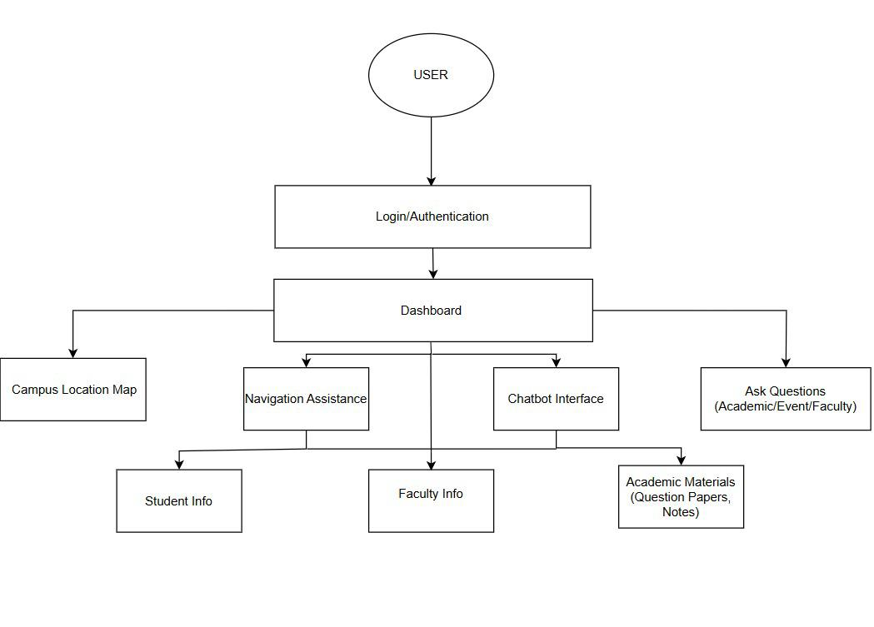**User:**

* Represents students, faculty, or visitors using the system.

**Login/Authentication:**

* Ensures secure access to personalized features.
* Authenticates users before granting dashboard access.

**Dashboard:**

* Central hub after login.
* Allows users to access all features like navigation, chatbot, and information**.**

**Campus Location Map:**

* Displays a detailed map of the campus.
* Helps users identify building locations.

**Navigation Assistance:**

* Guides users with step-by-step directions.
* Connects to student and faculty location info**.**

**Chatbot Interface:**

* Responds to user queries using text-based interaction.
* Linked to both faculty info and academic materials.

**Ask Questions (Academic/Event/Faculty):**

* Users can ask specific questions.
* Retrieves relevant answers from institutional databases**.**

**Student Info:**

* Shows class schedules, profile, and related student data.

**Faculty Info:**

* Displays office locations, availability, and contact info.

**Academic Materials:**

* Provides question papers, lecture notes, and other study materials.

**6.2 DATAFLOW DIAGRAM**

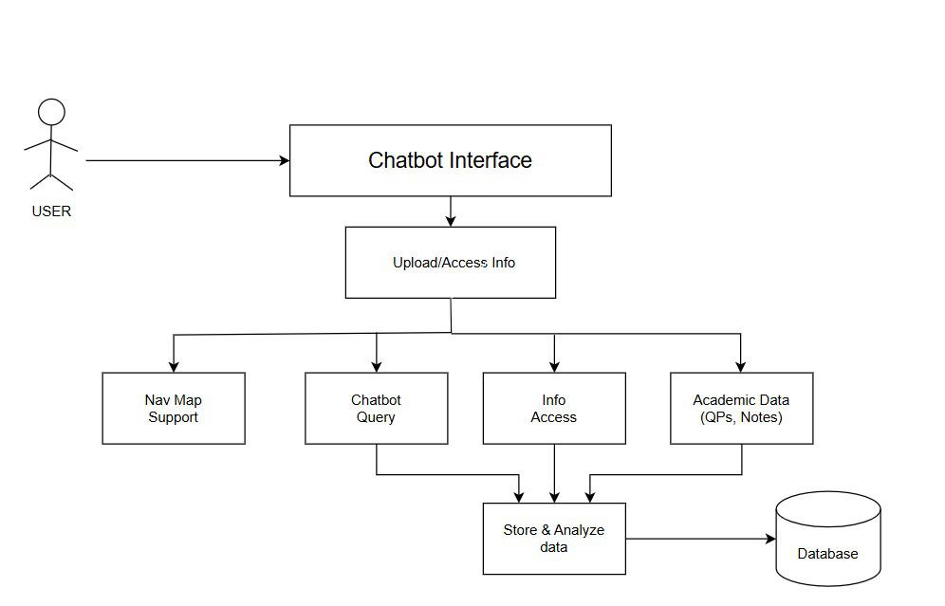

The diagram shows how a user interacts with the **Chatbot Interface**, which serves as the main point of communication. Through this interface, users can **upload or access information**, such as navigation support, chatbot queries, general information, and academic data (like question papers and notes).

All these services feed into a **data storage and analysis system**, which processes the inputs and stores them in the **database** for future use. This flow ensures that user queries are answered in real-time while also building a repository of useful data to improve system performance and accuracy over time.

**6.3 ER DIAGRAM**

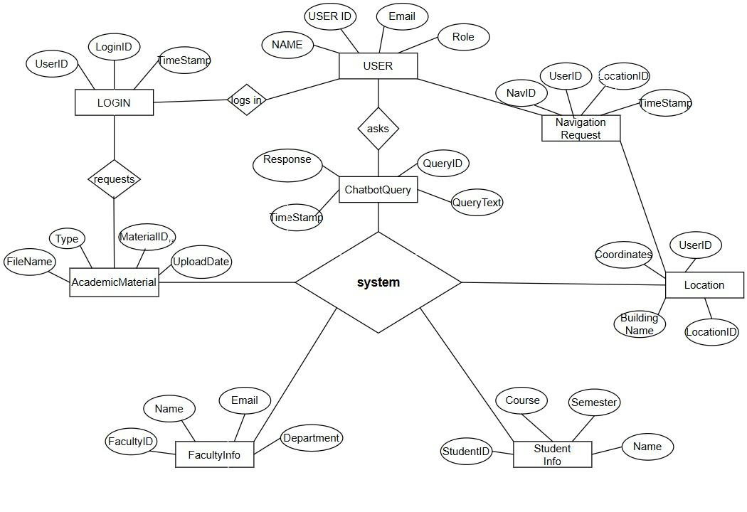**USER**

* Attributes: USER ID, Name, Email, Role
* Relationships:
  + *logs in* → LOGIN
  + *asks* → ChatbotQuery
  + *requests* → Navigation Request

**Login**

* Attributes: LoginID, UserID, TimeStamp

**ChatbotQuery**

* Attributes: QueryID, QueryText, Response, Timestamp

**Navigation Request**

* Attributes: NavID, UserID, LocationID, Timestamp

**AcademicMaterial**

* Attributes: MaterialID, FileName, Type, UploadDate

**FacultyInfo**

* Attributes: FacultyID, Name, Email, Department

**StudentInfo**

* Attributes: StudentID, Name, Course, Semester

**Location**

* Attributes: LocationID, UserID, Building Name, Coordinates

**6.4 Sequence Diagram**

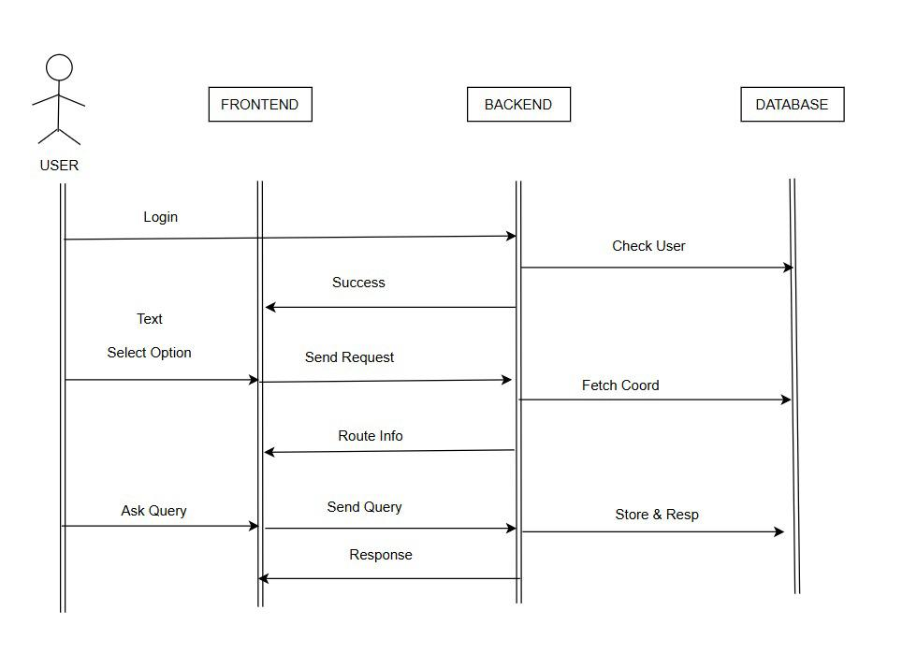

this **sequence diagram** illustrates the interaction flow among a **user**, **frontend**, **backend**, and **database** in a chatbot-based navigation and query system:

1. The **user logs in** via the frontend, which forwards the credentials to the backend.
2. The **backend checks the user** details with the **database**. On success, a confirmation is sent back to the frontend.
3. The user selects an option (e.g., navigation), and the frontend sends a **request** to the backend.
4. The **backend fetches coordinates** from the database and sends the **route information** back to the frontend.
5. The user may also **ask a query** via the frontend. The frontend sends the **query** to the backend.
6. The backend then **stores the query and retrieves a response** from the database.
7. Finally, the **response is returned** to the frontend and shown to the user.

# REFERNCES

**Gryzun, L. E., Shcherbakov, O. V., & Bida, B. O. (2023**): Development of the information system for navigation in modern university campus. It analyzes indoor navigation challenges, evaluates existing systems, and specifies functional requirements, providing a comprehensive foundation for campus navigation projects.

**Mohanapriya, M., Sheryl Sharon, G., Barathkumar, S., Rohit Vikaas, P., Harsha Vardhan, P., & Chanduru, A. (2024).** Campus Navigator Pro: An immersive campus navigation system. International Journal for Research in Applied Science and Engineering Technology, 12(2), 1121–1127

**Brunello, A., Montanari, A., & Saccomanno, N. (2024).** A framework for indoor positioning including building topology. IEEE Access, 12, 114959–114974.

**Situm Technologies. (2024).** Indoor navigation and indoor wayfinding for university campuses. Situm Technologies White Paper.

**MapsIndoors. (2024**). AAU Maps: A case study on campus navigation. MapsIndoors Case Study. showcasing how digital maps and real-time data improve navigation and information access for students and visitors.

**Navigine. (2024).** University indoor navigation solutions: Enhancing campus experiences. Navigine Technical Report. This technical highlighting features like real-time tracking, accessibility support, and integration with campus services to streamline navigation and information access.